CS 543 Machine Problem 2 Report

In this machine problem, feature detection is implemented with three different methods: regular Laplacian of Gaussian (adjusting sigma and filter size), Laplacian of Gaussian by down sampling (reducing image size instead of increasing filter size), and difference of Gaussian approximation (DoG).

Running time in seconds is listed in the following table. Note that it is the running time only for the filtering part to get all the layers, as non-maximum suppression is the same for all three methods:

|  |  |  |  |  |
| --- | --- | --- | --- | --- |
|  | pixel size | Regular Laplacian filtering (sec) | Laplacian filtering by down sampling (sec) | Difference of Gaussian (sec) |
| Bufferfly | 575736 | 23.328133 | 0.422733 | 2.168122 |
| Einstein | 307200 | 38.659573 | 0.494112 | 4.194936 |
| Fish | 279544 | 21.24002 | 0.4218 | 1.920568 |
| Sunflower | 117096 | 15.567497 | 0.403524 | 1.443629 |
| Statue of Liberty | 140725 | 5.049645 | 0.336754 | 0.837122 |
| SouthPark | 208046 | 5.74996 | 0.377761 | 1.142391 |
| Kiev | 628860 | 20.112139 | 0.562164 | 2.876844 |
| Migration | 802800 | 56.535004 | 1.634088 | 7.189331 |

**Time Analysis**:

Assume p: # of pixels, n: # of layers

Regular Laplacian:

p*12 + p*22+ ..+ p*n^2 = **O(pn3)** as sigma is linear to n, and each iteration cost linear to sigma2.

Down Sampling:

p+p/22+p/42+…+p/(2n)2 = **O(p)** as sigma is a constant, and the down sampled image is 1/(2n) of the original image each time.

Difference of Gaussian:

**O(np)** as Gaussian filters are algorithmically separable.

Therefore, the analysis matches the results well as shown in the table and the plot: Down sampling is the fastest, then DoG, and Regular Laplacian is the slowest.

**The results for the 4 given and the 4 selected images are shown as below:**

Each image has 3 outputs obtained through the 3 methods. Refer to the files for full resolution.

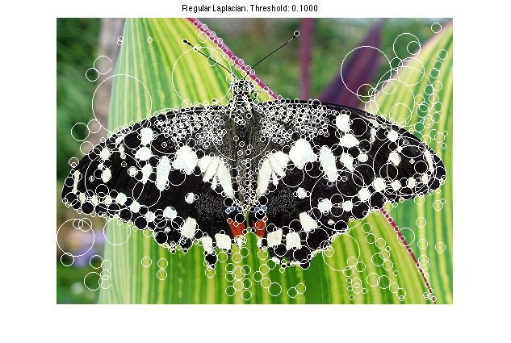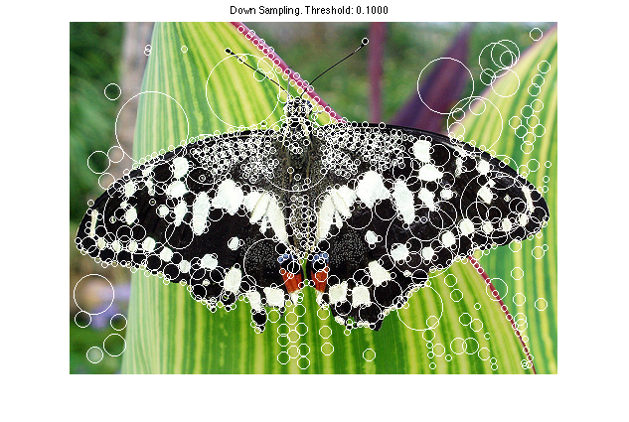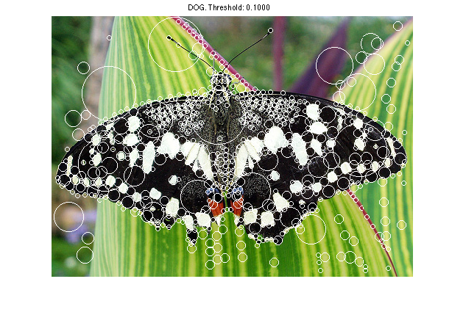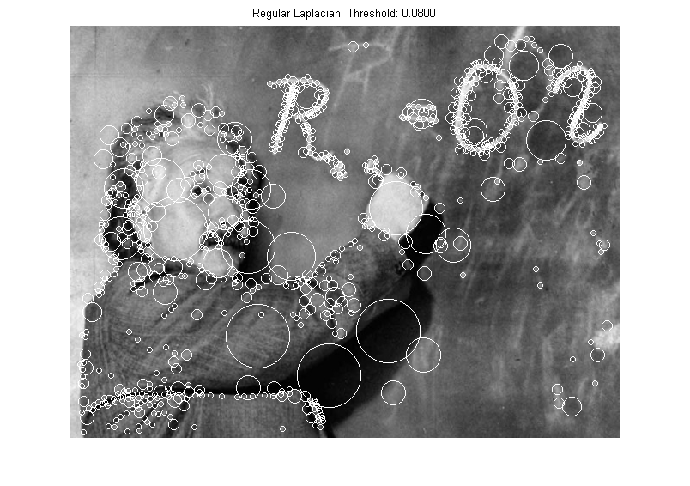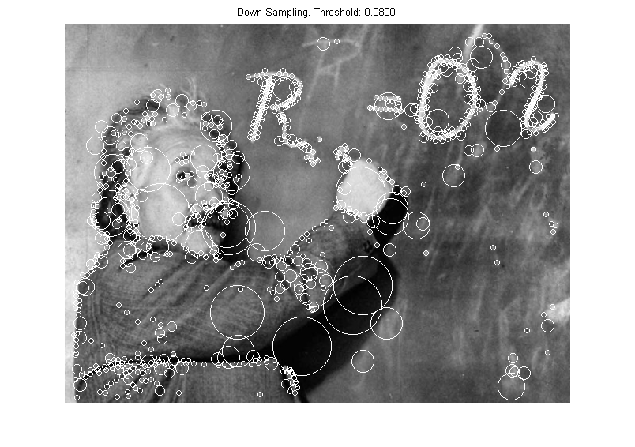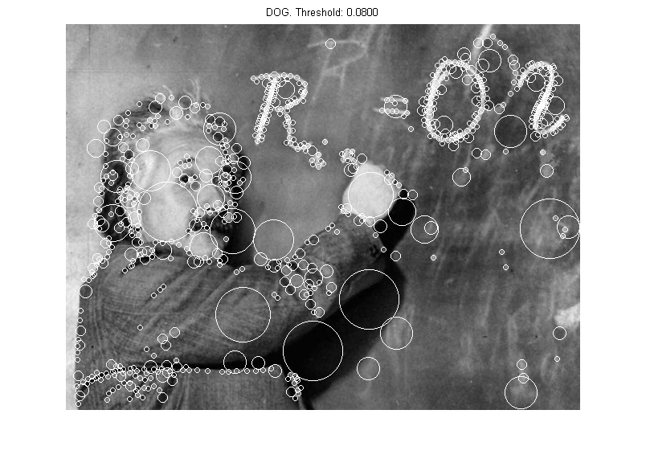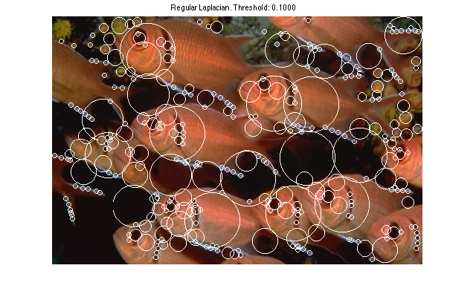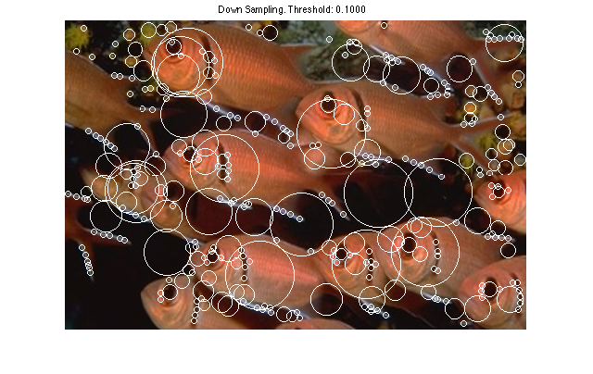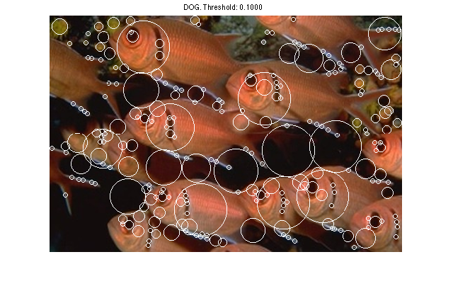

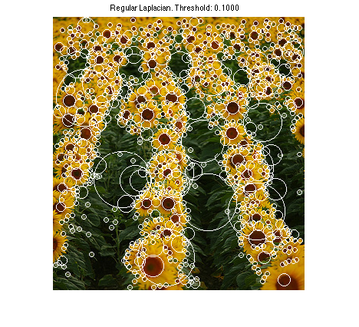

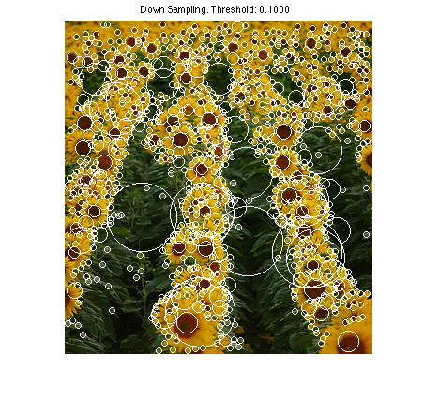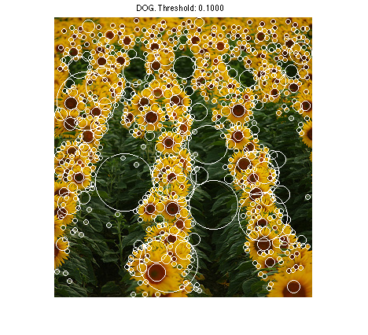

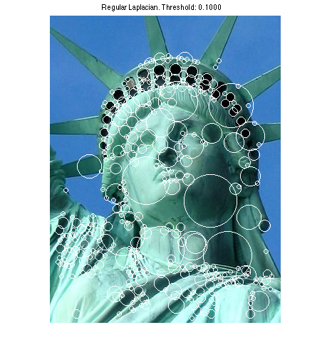

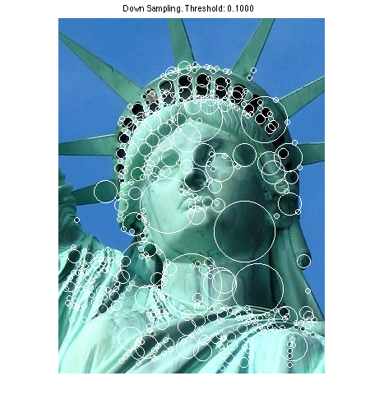

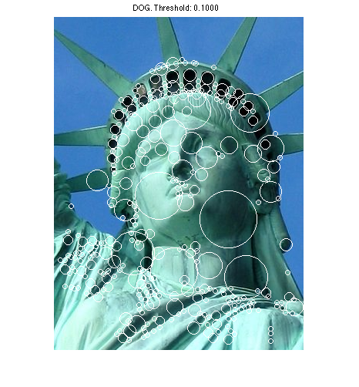

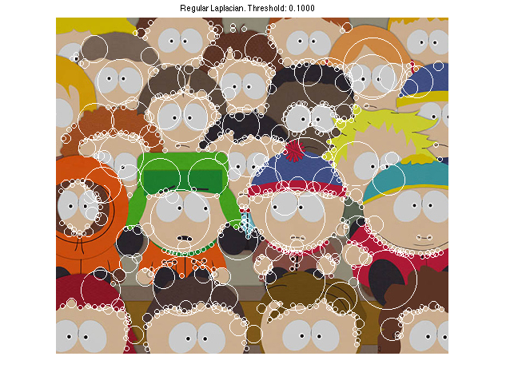

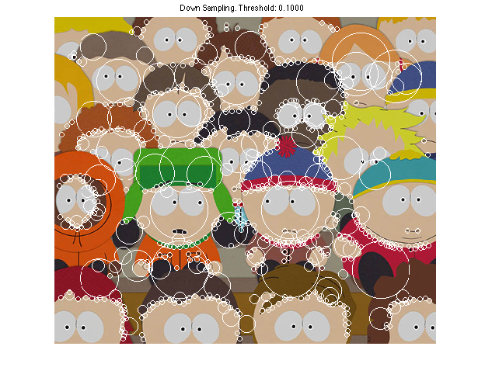

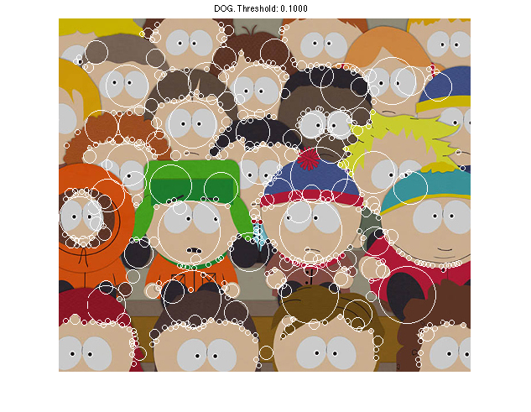

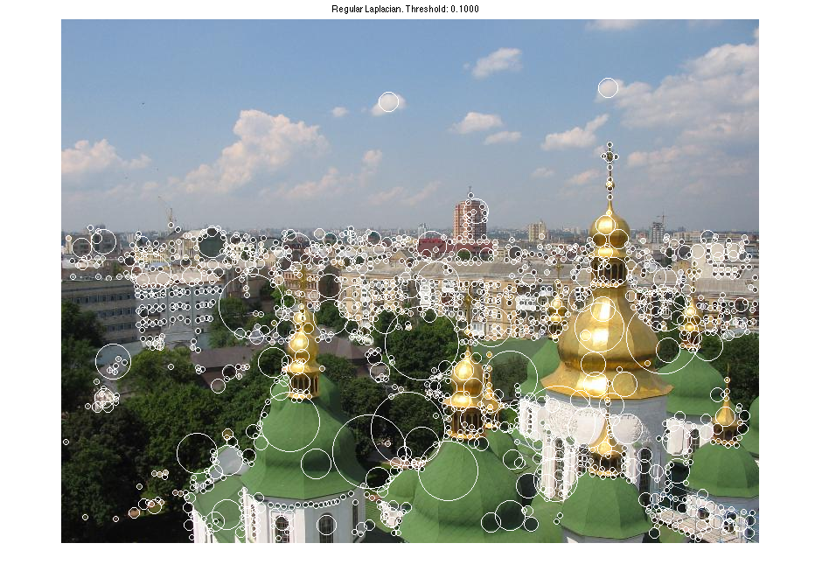

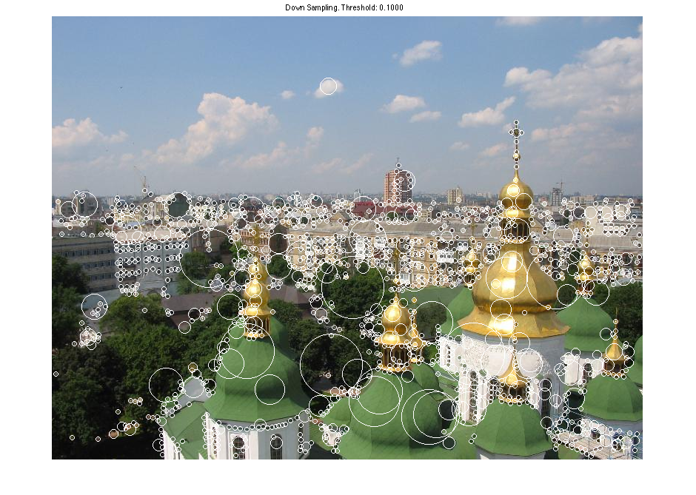

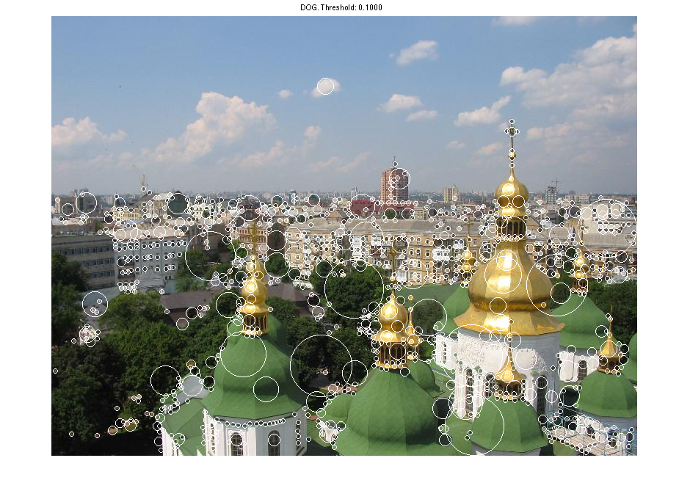

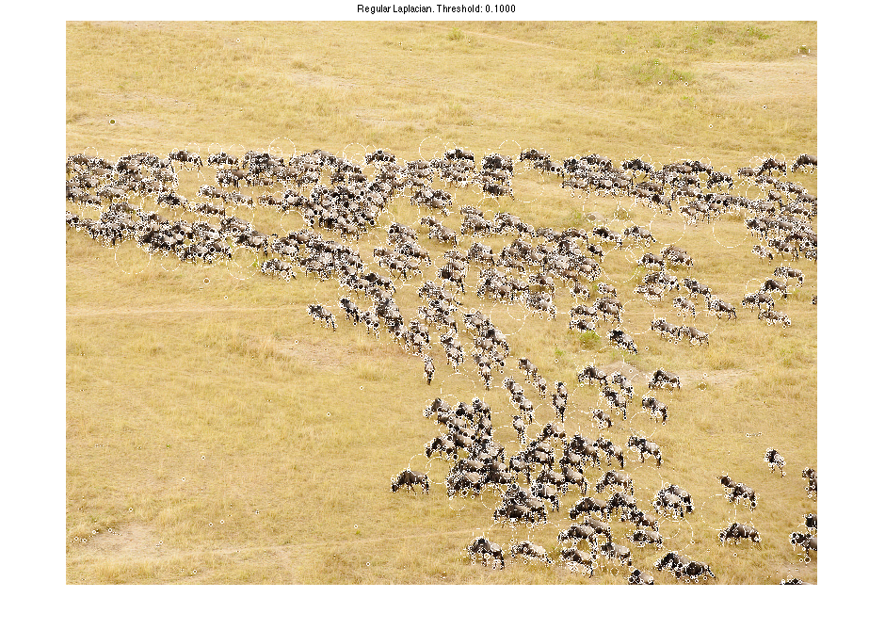

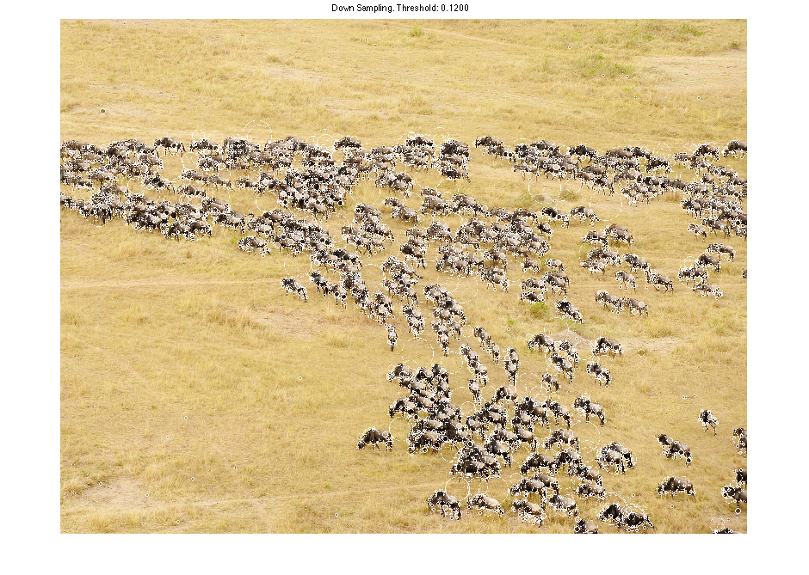

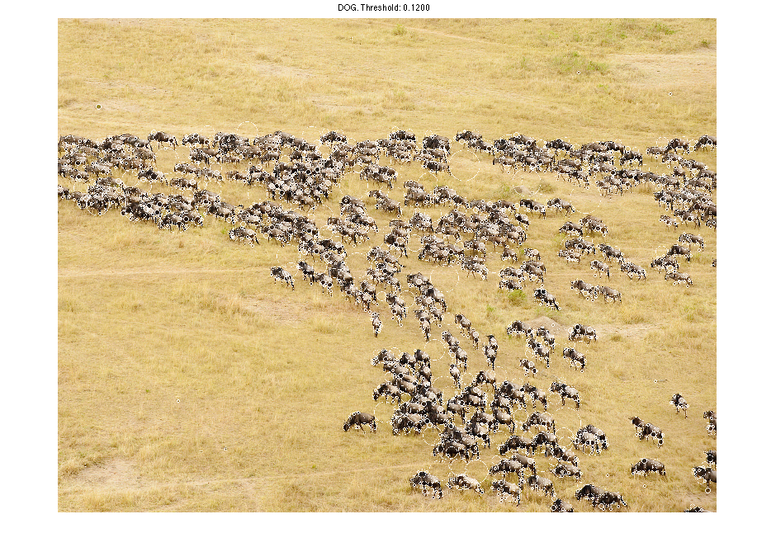

**Interestingness:**

The following technique is used for normalization on DoG:

The paper has the following equation illustrating the relationship between DoG and Laplacian of Gaussian.

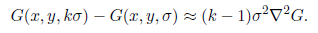

Since sigma2 is multiplied for normalization after Laplacian of Gaussian. Therefore, to normalize DoG, 1/(k-1) is simply multiplied, in which case the threshold can be set in the same scale as Laplacian of Gaussian and down sampling method for non-maximum suppression, and thus simplified the process.

**Parameters:**

Image resize function: ‘bilinear’ is chosen to resize the image for down sampling because it preserves the average pixel intensity and prevents skipping pixels when scaling down the image.

Threshold for non-maximum suppression is chosen to be between .08 and .12 after the normalization, as the maximum value after the normalization in each layer lies between .2 to .5. Note that negative values are preserved by taking the absolute value instead of their squares from the initial filtering.

Local domain is chosen to be sigma/2. It is the range of pixels across layers used to check for non-maximum suppression. Being too small will too many local maximum in a nearby region, and being too large will filter out many other local maximums.

k for DoG is 21/2 for best practice as suggested in the paper.

**Extra credit:**

Difference of Gaussian method is implemented. The results were shown above with the regular Laplacian of Gaussian and the down sampling method.